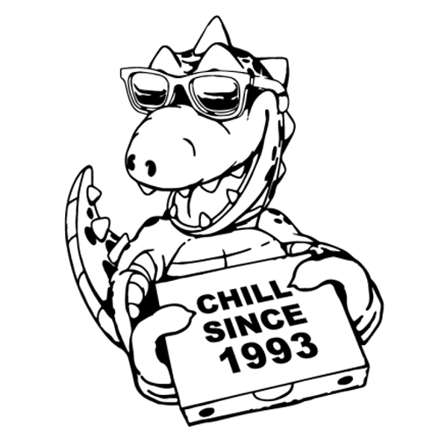

NEWS RELEASE

For Immediate Release For More Information:

December 5, 2023 Maya Banda

Public Relations Director

617-555-1234

[mbanda3@depaul.edu](mailto:mbanda3@depaul.edu)

**Brandy Melville opens a new pizza restaurant Chill since ‘93 in Chicago**

CHICAGO, IL—Chill Since’93 will be opening a new location in Chicago's Lakeview neighborhood, CEO Silvio Marsan announced on December 1. Chill Since’93 will be opening their third location in Chicago, a pizzeria and coffee shop influenced by Brandy Melville’s storefront locations.

“We wanted to announce this new location in Chicago as the steppingstone to expand Chill Since’93 beyond Los Angeles. We wanted to bring West Coast cuisine to Midwesterners for a long time and thought that Chicago, well known for its food would be the perfect place to open our third location.” said Silvio Marsan.

Inside, Chill since’ 93 looks Instagram filtered, all bleached wood and muted color palette, everything from the chalkboard menu and fairy lights, it is the place to be for any teenager living in Chicago. There are little white patio tables that decorate the outside of this tiny pizza shop, it truly feels like you are in a pizzeria off the beach in Malibu amidst the Chicago Northside.

Chill Since’93 will be partnering with Steppenwolf where audiences can use their tickets to receive a special restaurant offer during the month of February during Chicago Theater Week. Ticketholders will have 20% off when presenting their ticket on the day of the performance.

“We wanted to open Chill Since’93 prior to Chicago Theatre Week. We wanted Chicagoans to get a tase and feel of our restaurant before the theatre doors opened. Being winter, we wanted Chicagoans the opportunity to dine as if they were in the California sun.” said Silvio Marsan.

Chill Since’93 will be hosting its grand opening on December 6 of 2024, nestled in the bustling shopping and dining district on Southport Avenue.

Silvio Marsan and his son Stefan founded Brandy Melville in Italy in the early 80s and opened their first US store in 2009. The company has 133 locations and, in 2022, had revenues of 8.6 million.